**Milestone 5 Submission Document**

**Team 5:**

Vidisha Sawant

Prashant Shinde

Neerav Poriya

Raj Mehta

# Figma Link

<https://www.figma.com/file/yp1zBrVqssOfzq8ppgSK94/Student-Hub?node-id=0%3A1&t=vKW5IVYpy1n7ulEY-1>

# Student Hub

Our aim is to create an agnostic application to help cater needs of international students. Through this application, we try and answer the most common questions and doubts people have in relation to various things like accommodation, opening bank accounts, obtaining SSNs and university events, etc.

# Color Scheme and Font

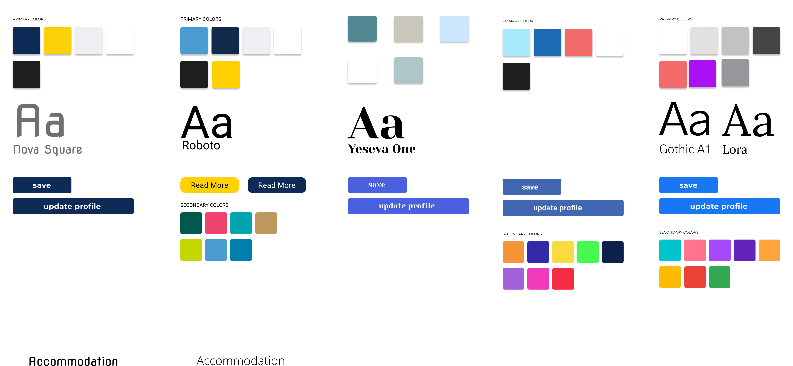

We started off by assigning each person on the team to come up with color schema for the website and we then followed the voting system and selected our second design from left to be our color scheme.

For the web application font, we went with “**Roboto**” and “**Open Sans**”.

# Application Pages and description

we went with the approach of showing the common task on home page:

* Places to visit
* Accommodation
* SSN
* Opening Bank Account
* State Id / License

And University centric tasks inside respective pages.

* Mentorship Program
* On-Campus
* Events
* Immunization

# Home Page

We have tried to keep the design simple and club all the common task together, where a student can interact with the website for common tasks which are not university centric. After Interviews and Survey, the 5 common task that we came up with were Places to visit, Accommodation, SSN, Opening Bank Account, State Id / License.

In the header too we have only 3 things Home, About Us and Contact Us section.

We do have a chat feature, which acts as a chat bot and if the answers are not available, then one can leave query and it will be answered within timeframe of 48 hours.

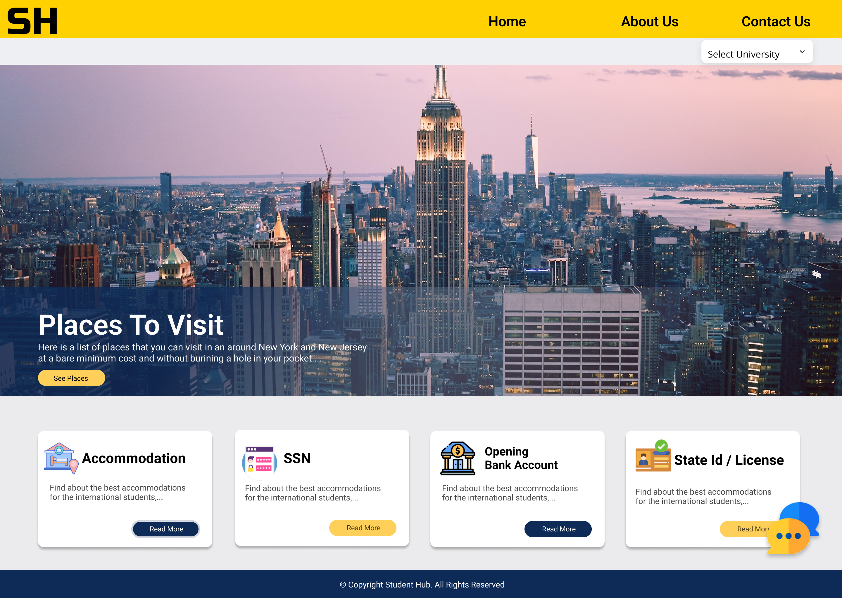

# Other Pages

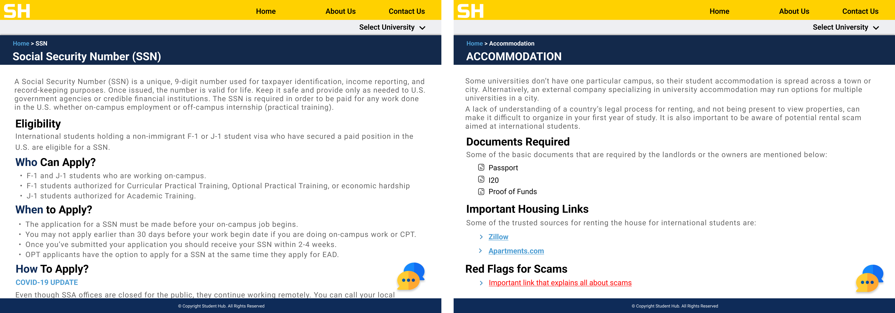

Here we can see two pages namely

SSN

* Student is redirected to SSN page from the home page on click of read more button.
* All the details related to Who, When & How are defined in the page.

Accommodation

* Student is redirected to Accommodation page from the home page on click of read more button.
* Detail related to documents that are generally required, Housing website links and how to avoid Scams.

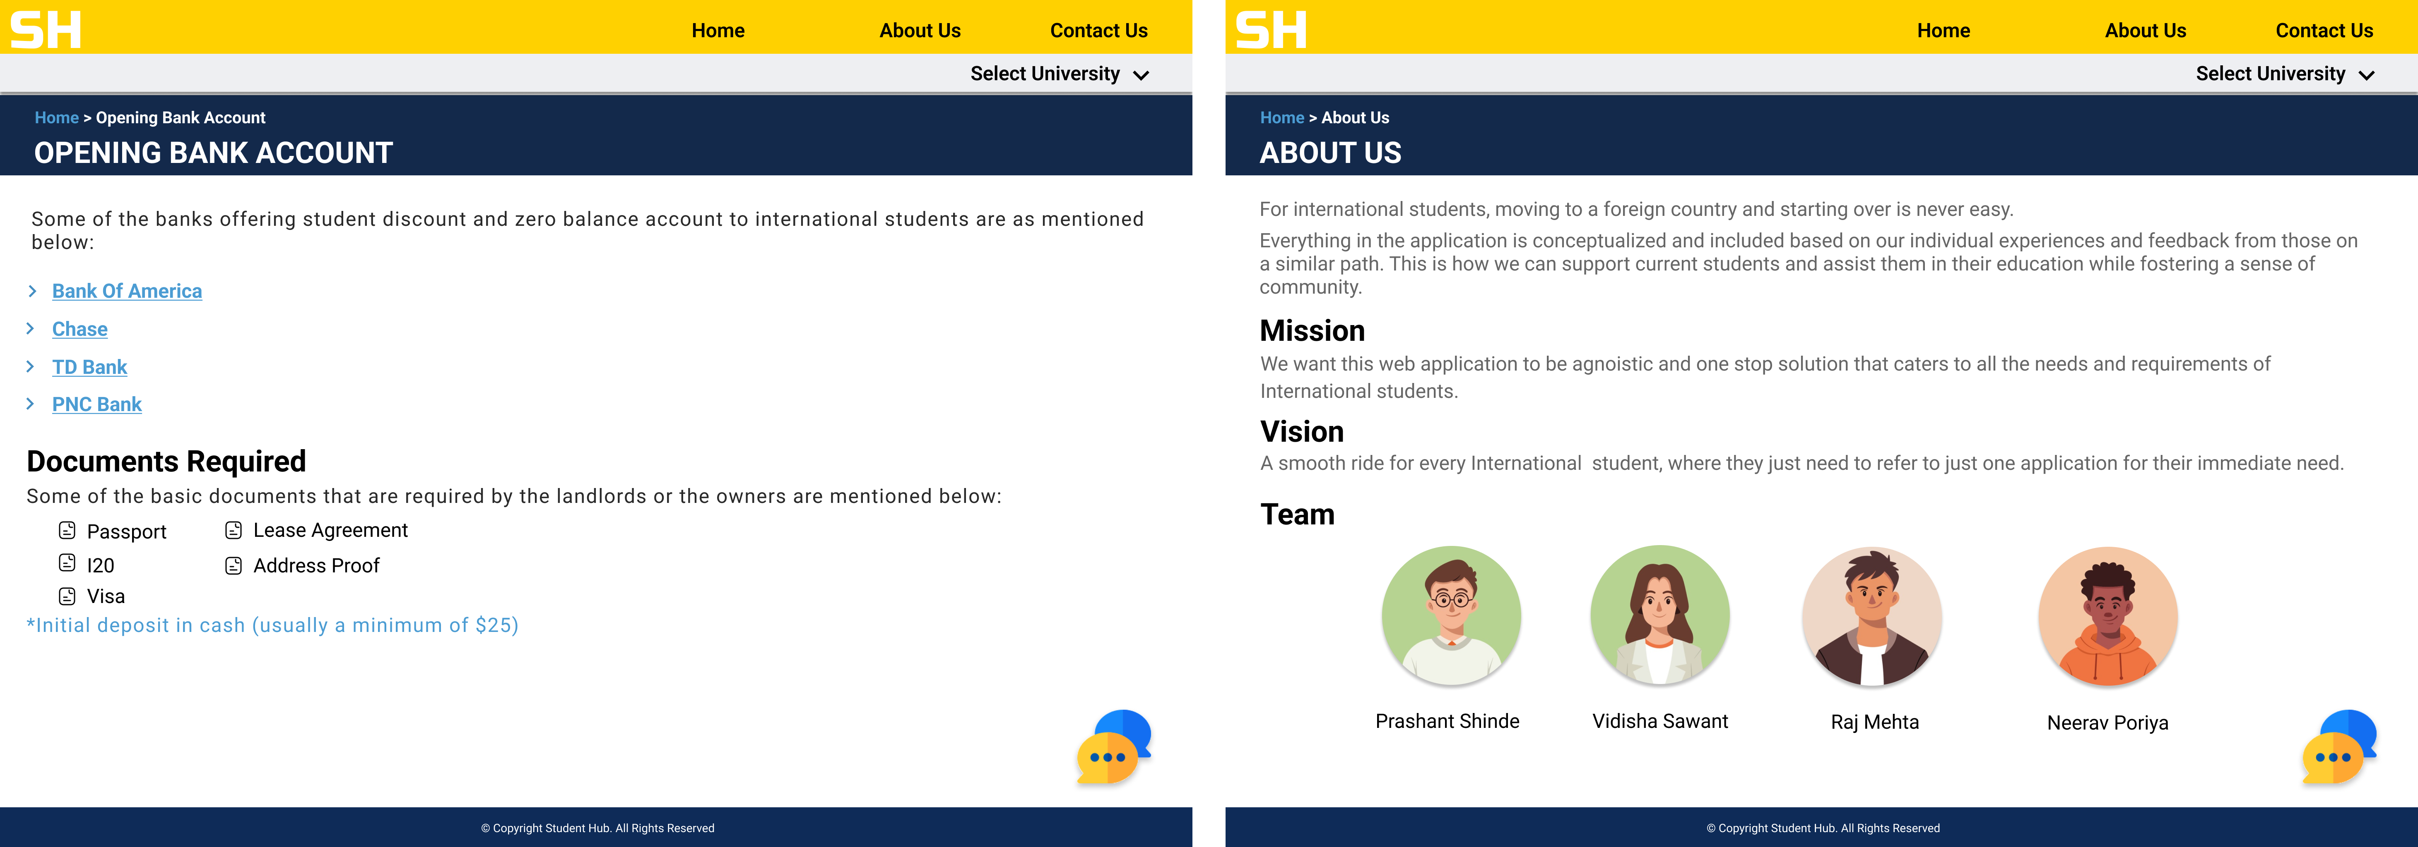

Opening Bank Account

* Redirects to the checking account pages for student’s page for individual banks
* It also describes about the documents required for opening of bank account.

About Us

This page talks about the idea behind the application, our Mission, Vision and then introduces users to the Team.

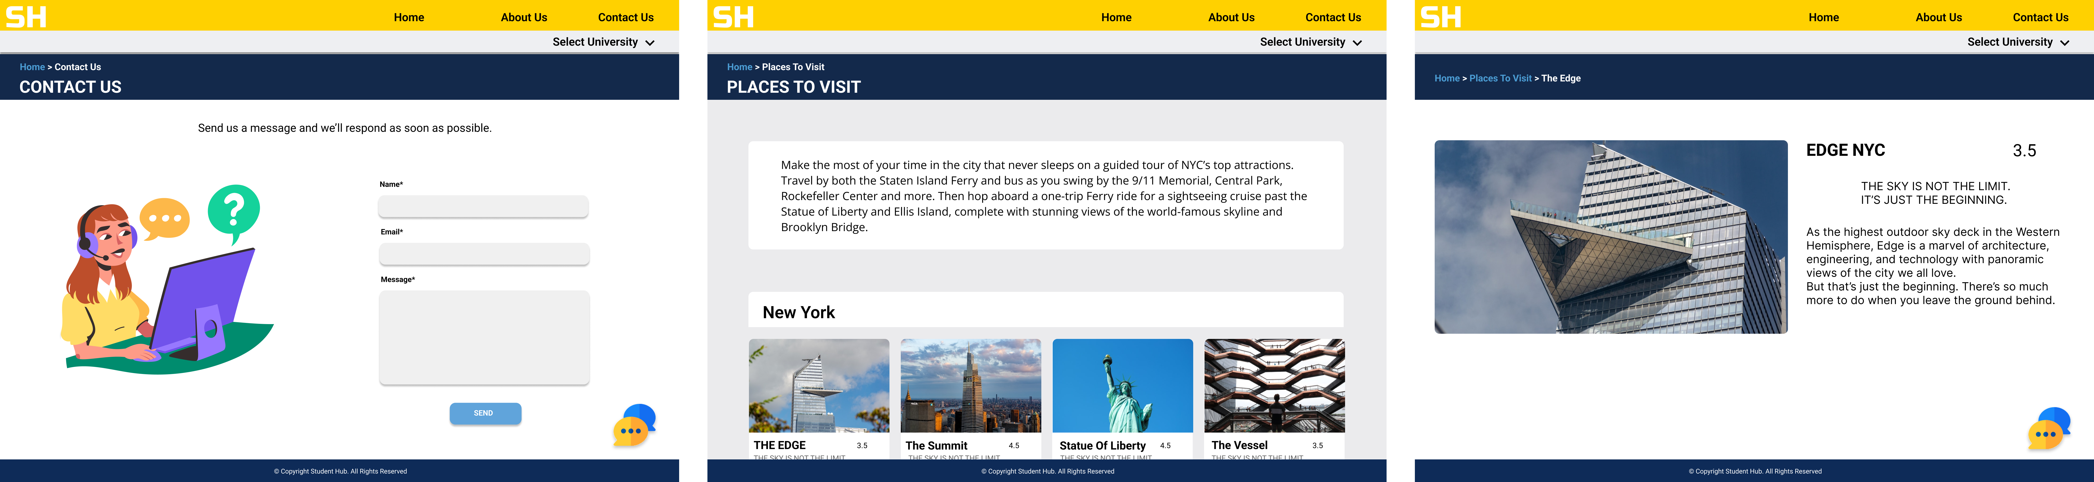

Contact Us

* It consists of basic form to submit queries and they will be answered within 48 hours.

Places To Visit

* Places to Visit, shows all the places that are famous and near around New York and New Jersey that are affordable and a bit budget friendly.

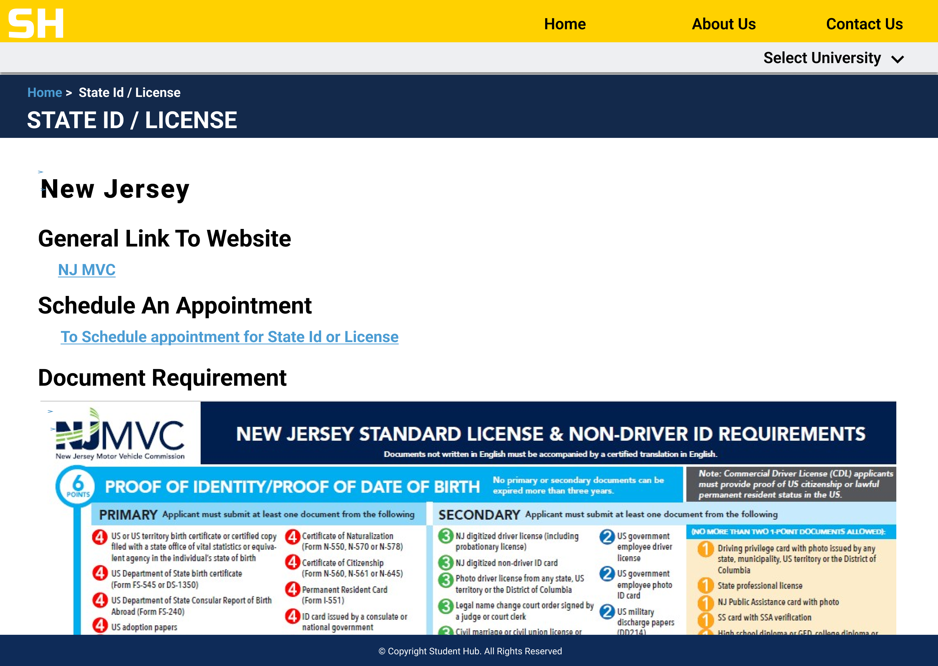

State Id / License

This page gives details about New Jersey and New York license and state Id document requirement and appointment booking link. It also has image showcasing the document requirement and the points associated with it.

# University-Centric Tasks

We have tried to keep the design simple and club all the common tasks together, where a student can interact with the website for common tasks which are university centric. After Interviews and Surveys, the 4 common tasks that we came up with were mentorship program, On- Campus, events, and Immunization.

In the header, we have only 3 things Home, About Us, and Contact Us section.

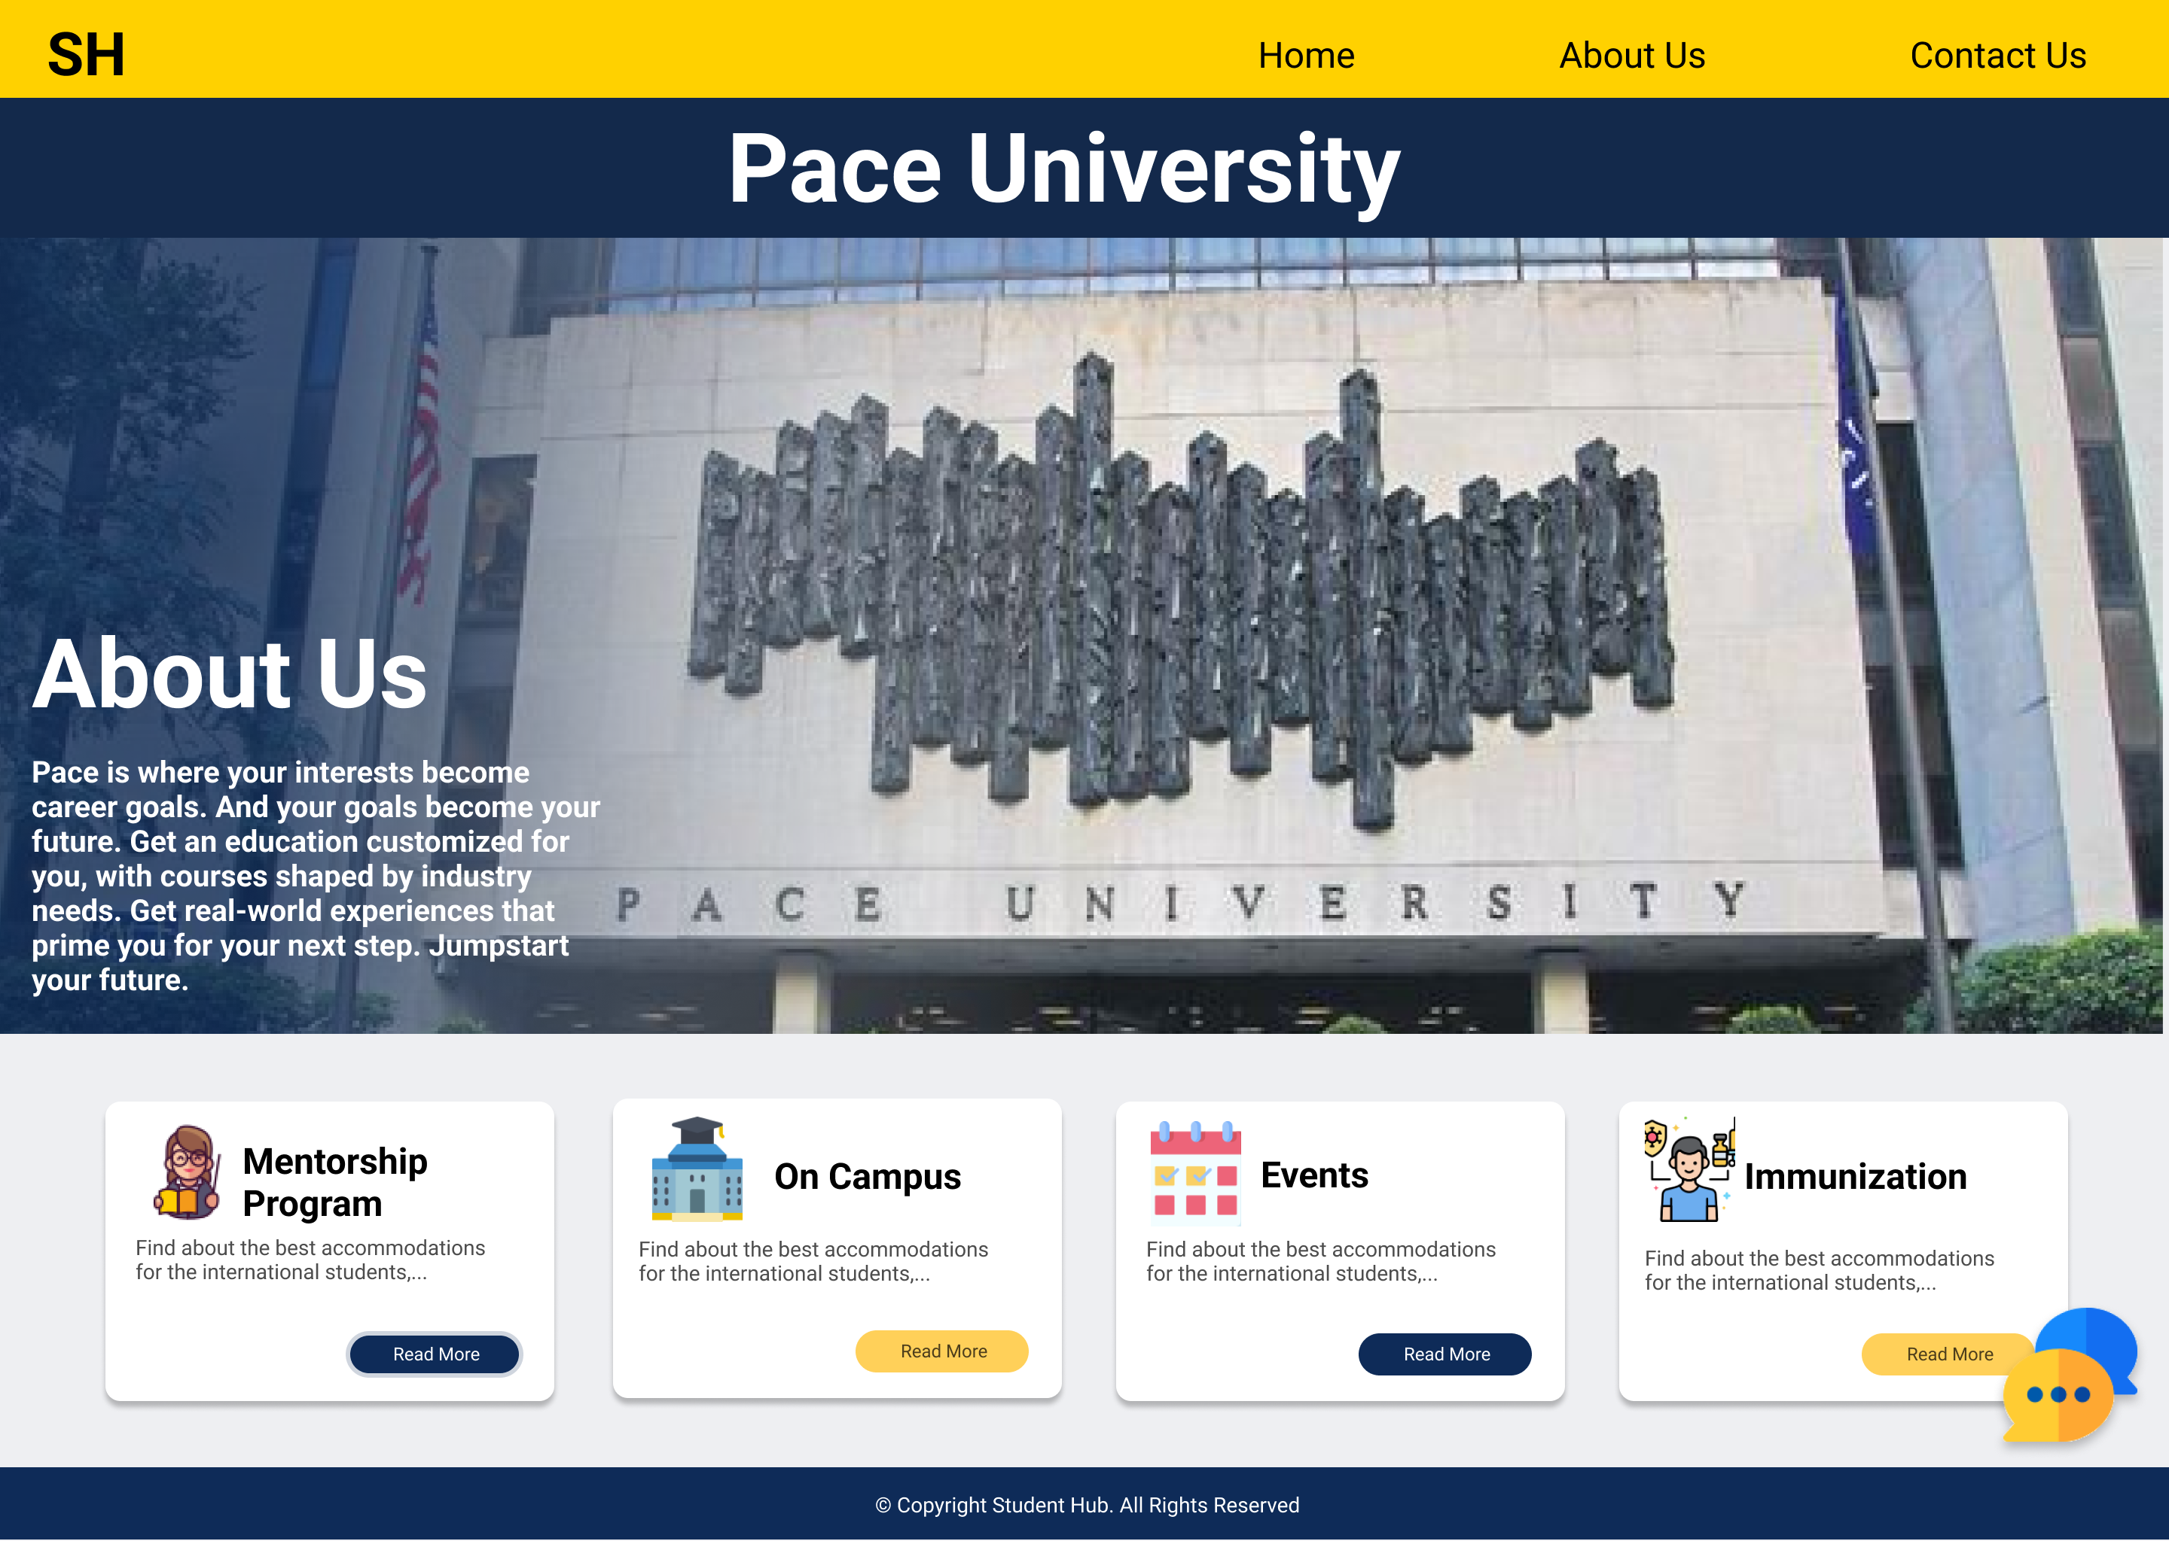

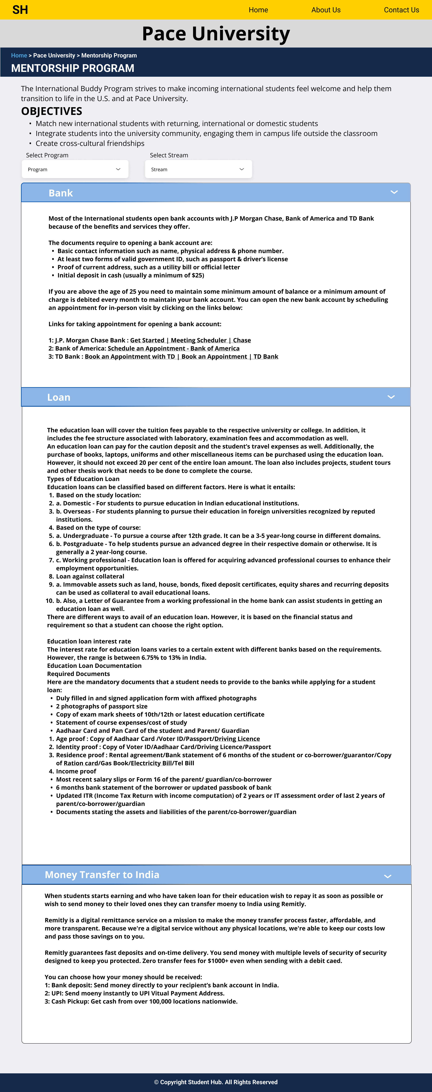

**Mentorship program:** The page help students with some of the most common tasks they need but don’t know how to proceed with it.

The mentorship program consists of 3 sub-parts:

* **Bank:** The Bank details consist of which are the most common banks for students in the USA, what documents are required, and how links how can they schedule an appointment.
* **Loan:** The Loan details consist of the procedure of applying for the loan in India, who is eligible for applying for a loan, and also what documents are required for the loan. The details also consist of what all various banks cover in their loan.
* **Money transfer to India:** The Students who start earning on-campus or get an internship and decide to send money to their loved ones or to repay the loan as soon as possible can send money using Remitly which is most used in the US for sending money to India.

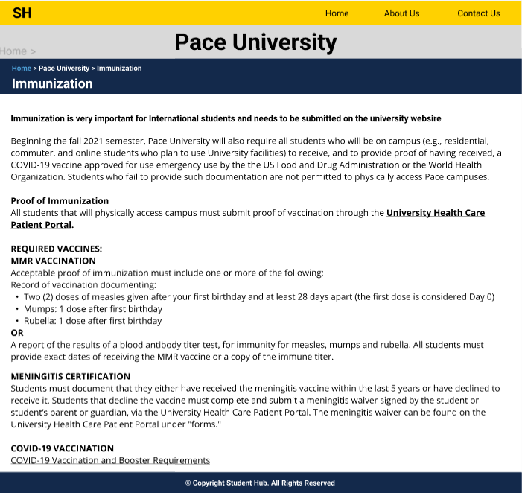

Immunization

* The immunization page consists of the details on how you can complete your immunization procedure and what documents are needed and which medical proof is required to change your immunization status to complete as well as the university health care link.

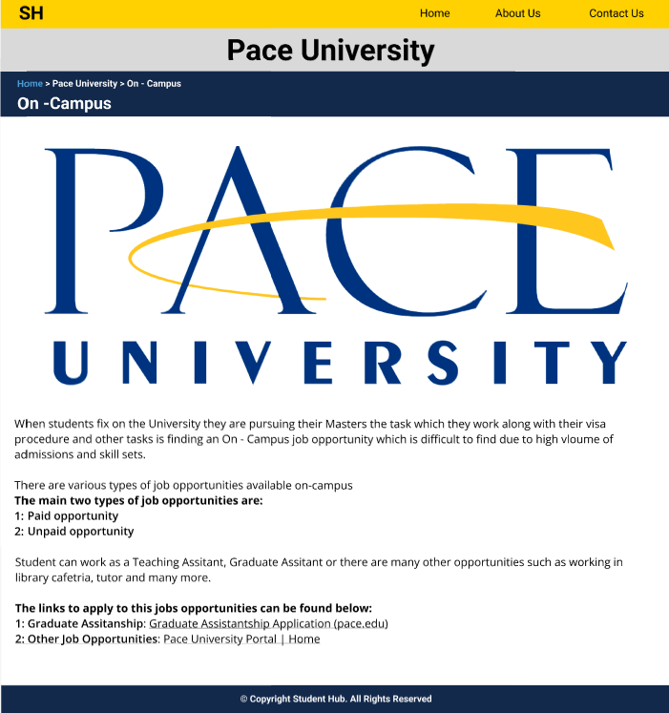

On–Campus:

* The On Campus gives details about where the students can apply for the opportunities and what types of opportunities are available for student on – campus.

Events:

* The Events page consists of details about the various events organized by clubs on campus and where they can reserve it.
* It consists of details of past events with few images.

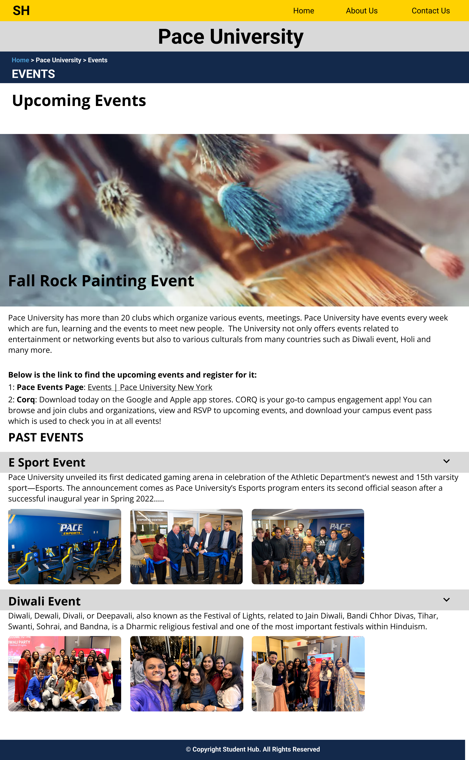

# Page Flow

The Home page links to different pages.

It consists of clickable features like Logo, About Us, Contact Us, Select University, Places to visit, Accommodation, SSN, Opening Bank Account, State Id / License, Chat feature.

This is an informative website, which provides international students with quick links to the features that are need of the hour for new students and upcoming students. The features were selected based on the Interview and Survey methodology and Ranking.

On Click of the read more button the button redirects user to the individual dedicated pages which are feature based. E.g., On click of the read more button on accommodation page will lead to the Accommodation page.

Almost all pages have identical layout for ease for use to the user and consists of information and useful links.

Note:

We are a little dicey on the Chat feature, so as to what will go in it and also whether to keep it on the home page and all the pages or make it university centric with WhatsApp button, so that they can directly leave a query for their mentors and then get a reply with 48hrs of timeframe. For the solution, we are currently conducting another survey for the same and based on its result will implement the final feature.

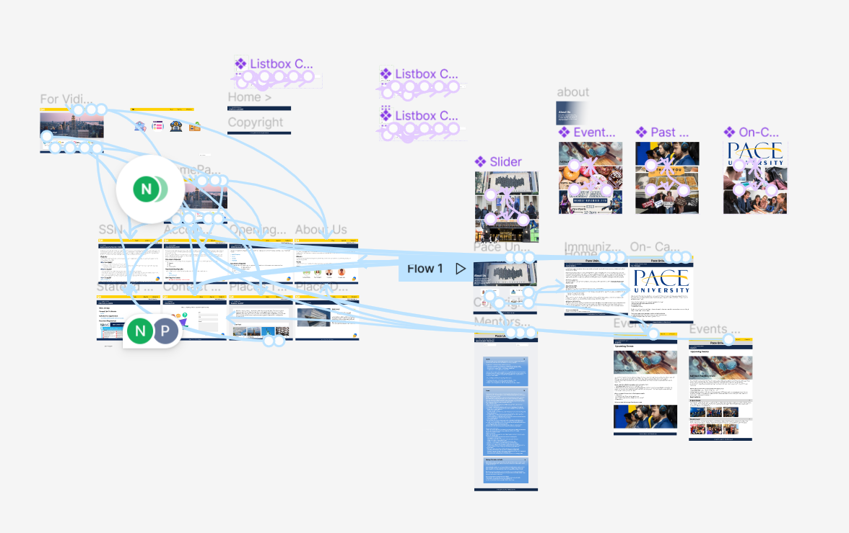

# Mobile View

Since the website is agonistic, it will be accessible both on the desktop and mobile. For the mobile view we have done few tweaks to beautify it a little and keep it light.

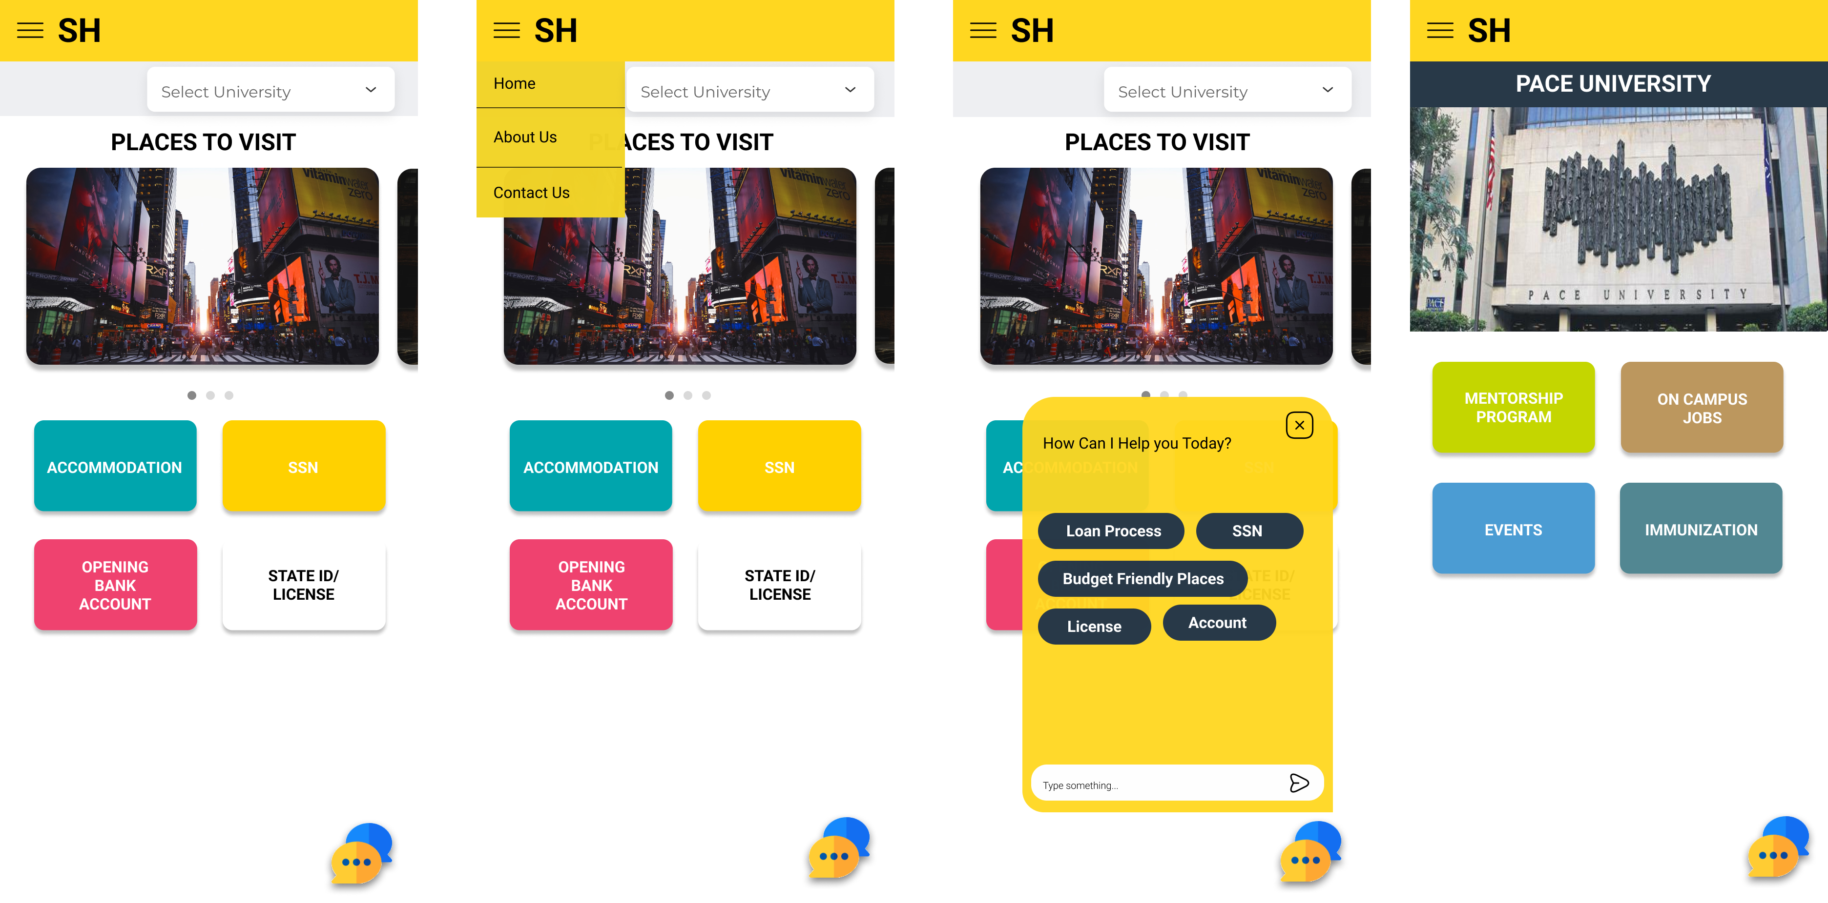

Here in the images, we can see that the navigation bar is all under hamburger menu. We also have the chat bot feature and a different University page when one selects the university. We have also created other internal pages and the design for the same are as mentioned below.

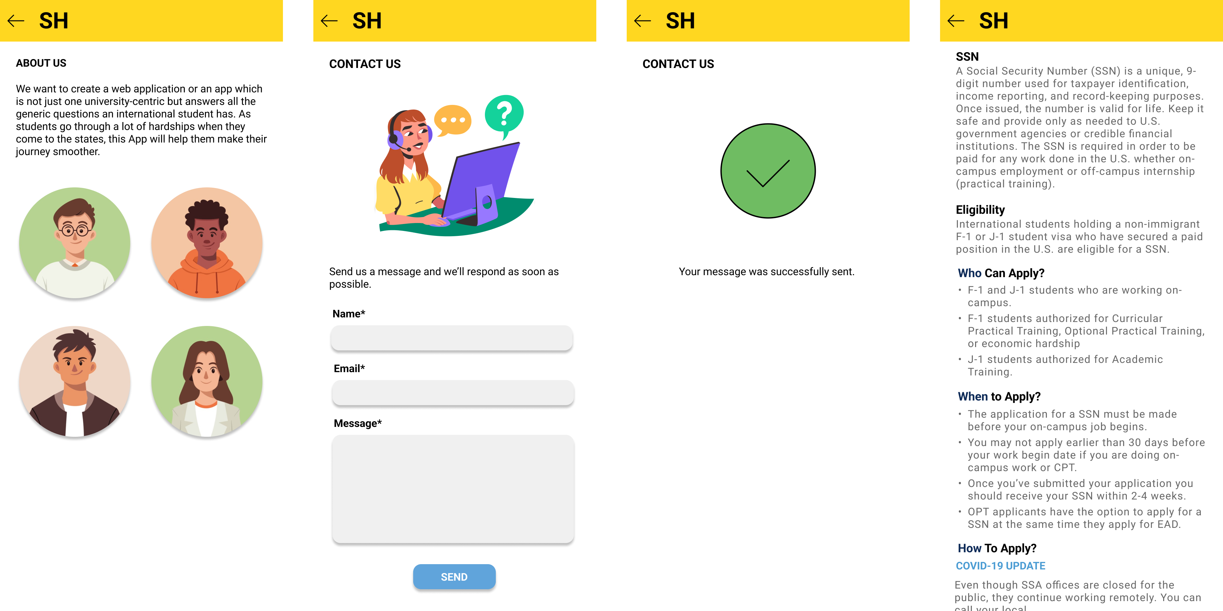

The Details of the pages are identical to the one on the main website.

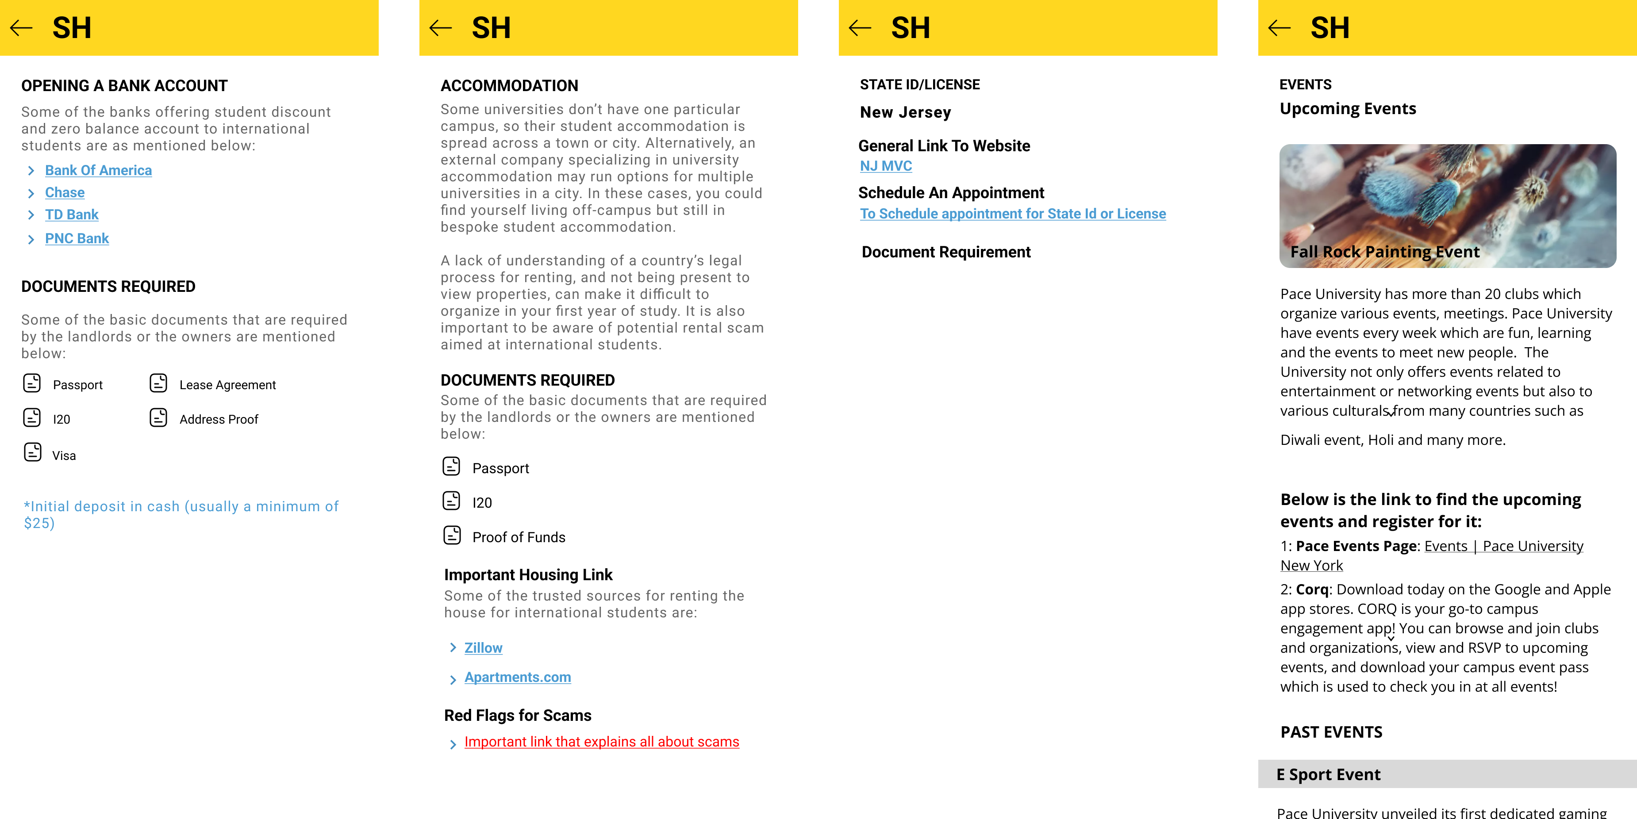

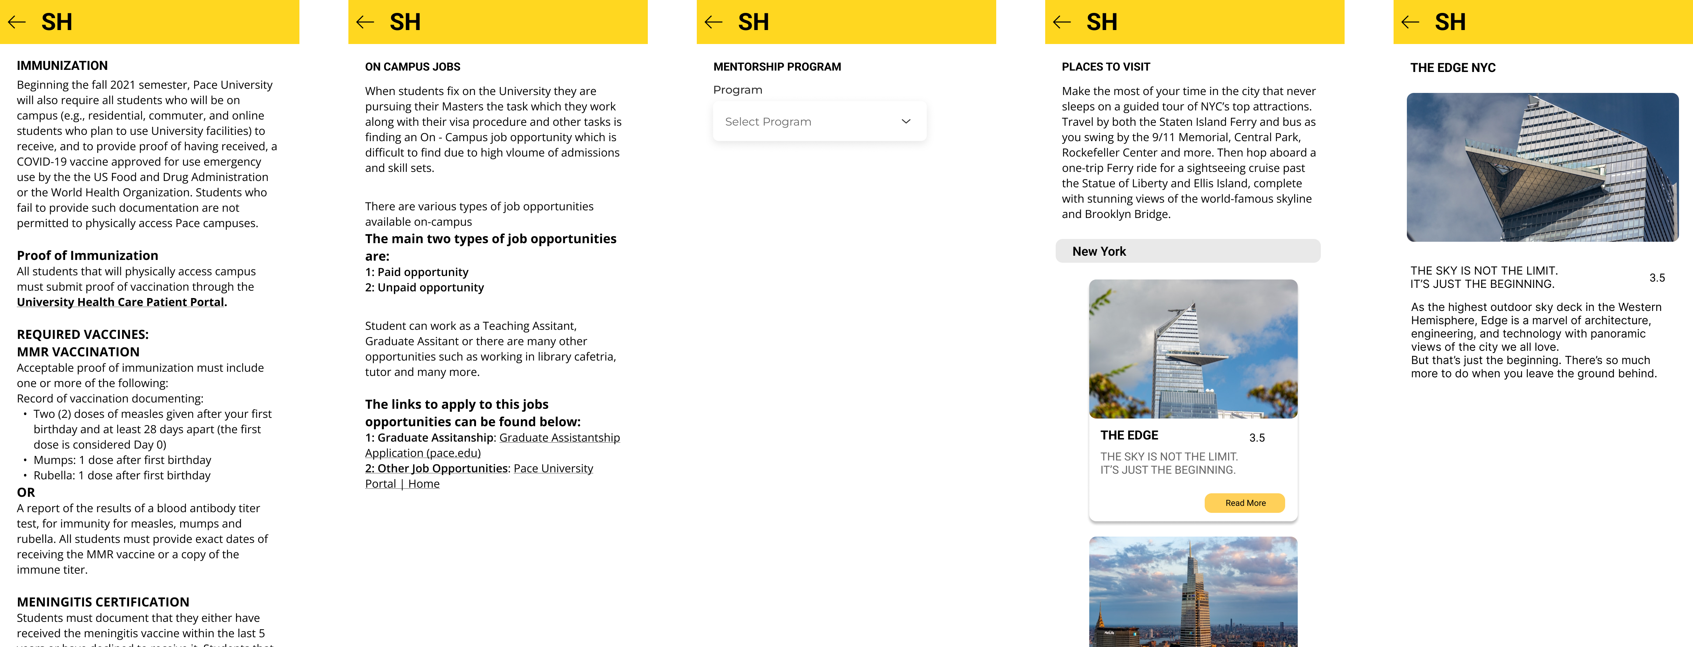

The Flow Diagram

The flow for the mobile view also remains the same only the navigation bar is converted to Hamburger menu.

